

**UNIVERSITY OF PETROLEUM & ENERGY STUDIES**

**College of Engineering Studies Dehradun**

**LAB FILE**

**Experiment 14**

Programme : B. Tech in Computer Science and Engineering with Specialization in DevOps

Course : Continuous Integration & Continuous Deployment Lab

No. of credits : 1

Semester : V

Session : July-December 2020

Batch : 2018-2022

Faculty : Dr. Hitesh Kumar Sharma

Submitted By:

Ingit Singhal

Sap id: 500068426

Roll No : R171218048

**Deploy Static HTML Website as Container using Docker**

**Screenshots**

**1. Edit the docker file and index.html .**

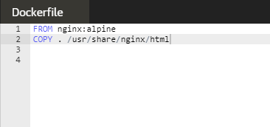

**2. Now build the container using the command given below.**

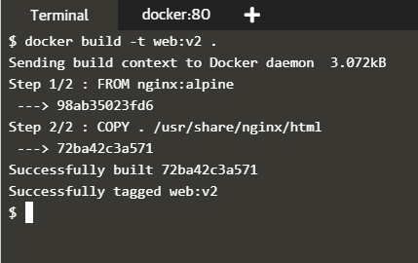

**3. Check whether the repo is created or not and then run the container.**

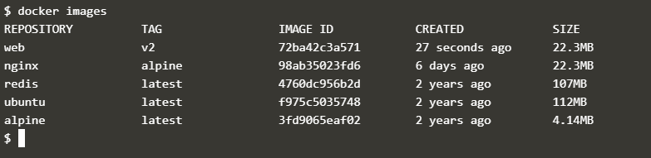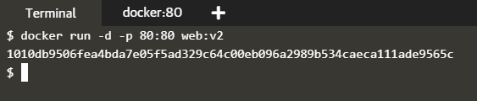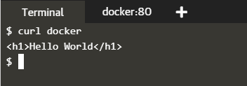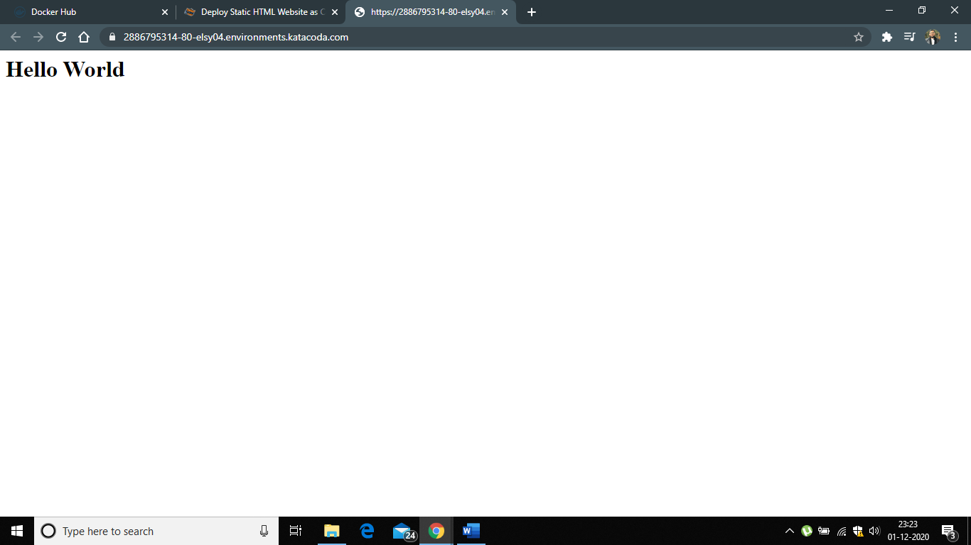

**4. Now connect to Docker Hub Account and push the repo on the account.**

